**USING SPRING FRAMEWORK TO MANAGE BEANS FOR JAVA GAMING APP**

**PROJECT STRUCTURE:**

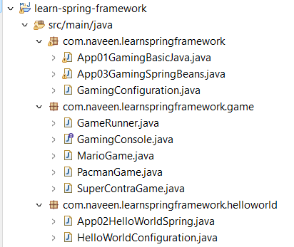

Already we have the Gaming class “App01GamingBasicJava”, but now we are going to make that using spring container.

1. Launch a **Spring Context**.
2. **Configure** the things that we want spring to manage.

**GamingConfiguration.java**

package com.naveen.learnspringframework;

import org.springframework.context.annotation.Bean;

import org.springframework.context.annotation.Configuration;

import com.naveen.learnspringframework.game.GameRunner;

import com.naveen.learnspringframework.game.GamingConsole;

import com.naveen.learnspringframework.game.PacmanGame;

@Configuration

public class GamingConfiguration {

    @Bean

    public GamingConsole game() {

        var game = new PacmanGame();

        return game;

    }

    @Bean

    public GameRunner gameRunner(GamingConsole game) {

        var gameRunner = new GameRunner(game);

        return gameRunner;

    }

}

**How do we pass game in GameRunner?**

1. Directly **call** the game method, like

var gameRunner = new GameRunner(game());

1. To pass game as the **parameter**.

public GameRunner gameRunner(GamingConsole game) {

        var gameRunner = new GameRunner(game);

        return gameRunner;

}

In the above example, we followed this approach. What would Spring do is, **it will take a bean named “game”, it will wire it to the gameRunner method.** It will pass game() bean as an argument to the method gameRunner(). When the gameRunner bean is created, the parameter “GamingConsole game” would be **get arguments from the game() bean**.

So, what we are doing here is, we are **creating a PacmanGame** and **wiring** it into the **gameRunner**.

**App03GamingSpringBeans.java**

package com.naveen.learnspringframework;

import org.springframework.context.annotation.AnnotationConfigApplicationContext;

import com.naveen.learnspringframework.game.GameRunner;

import com.naveen.learnspringframework.game.GamingConsole;

import com.naveen.learnspringframework.game.MarioGame;

import com.naveen.learnspringframework.game.PacmanGame;

import com.naveen.learnspringframework.game.SuperContraGame;

public class App03GamingSpringBeans {

    public static void main(String[] args) {

        try(var context =

                new AnnotationConfigApplicationContext

                    (GamingConfiguration.class)){

            context.getBean(GamingConsole.class).up();

            context.getBean(GameRunner.class).run();

        }

    }

}

Here we are get the gameRunner bean and run it. We have launching up the game and gameRunner as Spring beans. So**, game and gameRunner are spring beans** and we are **picking the beans from our Spring context** and running them.

**OUTPUT**:

